**DAILY ONLINE ACTIVITIES SUMMARY**

|  |  |  |  |  |  |  |  |  |
| --- | --- | --- | --- | --- | --- | --- | --- | --- |
| **Date:** | **21/05/2020** | | | | | **Name:** | **POOJA D S** | |
| **Sem & Sec** | **4th SEM 'B' Section** | | | | | **USN:** | **4AL18CS056** | |
| **Online Test Summary** | | | | | | | | |
| **Subject** | | **Microcontroller and Embedded System** | | | | | | |
| **Max. Marks** | | **30** | | **Score** | | | **12** | |
| **Certification Course Summary** | | | | | | | | |
| **Course** | **Marketing foundation** | | | | | | | |
| **Certificate Provider** | | | **Great Learning Academy** | | **Duration** | | | **1.5 hours** |
| **Coding Challenges** | | | | | | | | |
| **Problem Statement:** A user will input two strings, and we find if one of the strings is a sub sequence of the other. Program prints “yes” if either the first string is a sub sequence of the second string or the second string is a sub sequence of the first string. Assume that, the length of the first string is smaller than or equal to the length of the second string. Assume that, the length of the first string is smaller than or equal to the length of the second string. | | | | | | | | |
| **Status: completed** | | | | | | | | |
| **Uploaded the report in Github** | | | | | **yes** | | | |
| **If yes Repository name** | | | | | <https://github.com/dspooja/lockdown-coding> | | | |
| **Uploaded the report in slack** | | | | | **yes** | | | |

Online Test Details: (Attach the snapshot and briefly write the report for the same)

Certification Course Details: (Attach the snapshot and briefly write the report for the same)

Coding Challenges Details: (Attach the snapshot and briefly write the report for the same)

ONLINE TEST DETAILS:

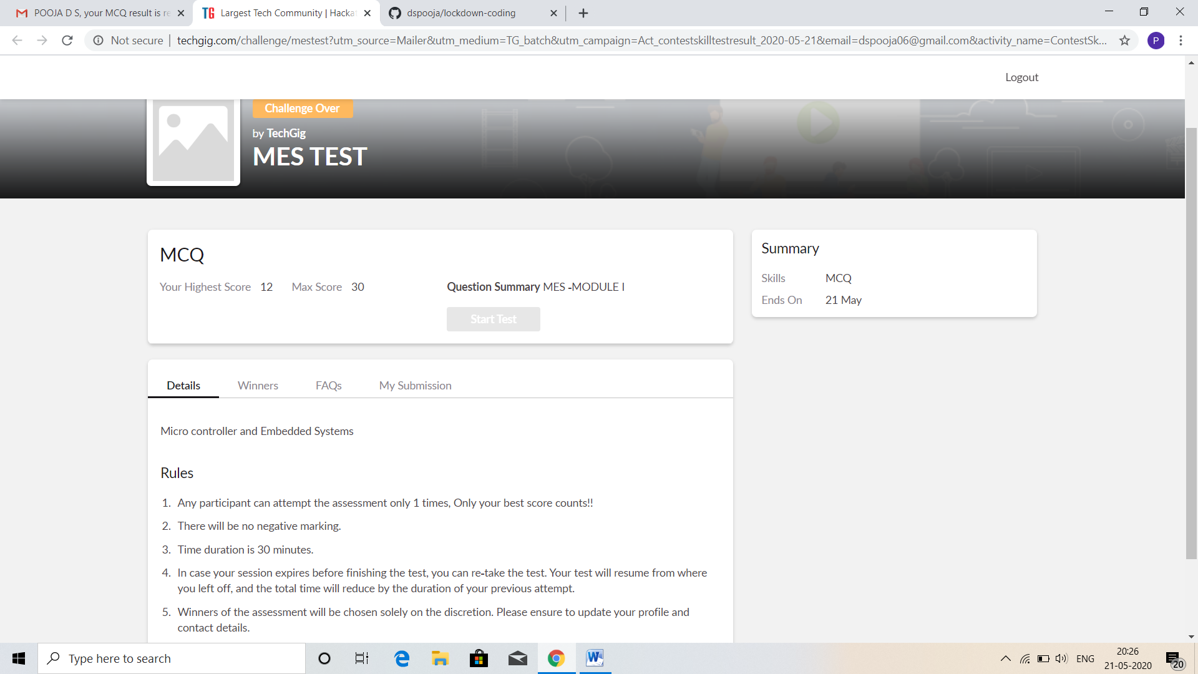

CERTIFICATION COURSE DETAILS:

* As continuation of the online course of Marketing Foundation.
* **The concepts covered by today are:**
* Customer value Analysis, Satisfaction & Loyalty
* Customer Lifetime Value & Customer Retention-2

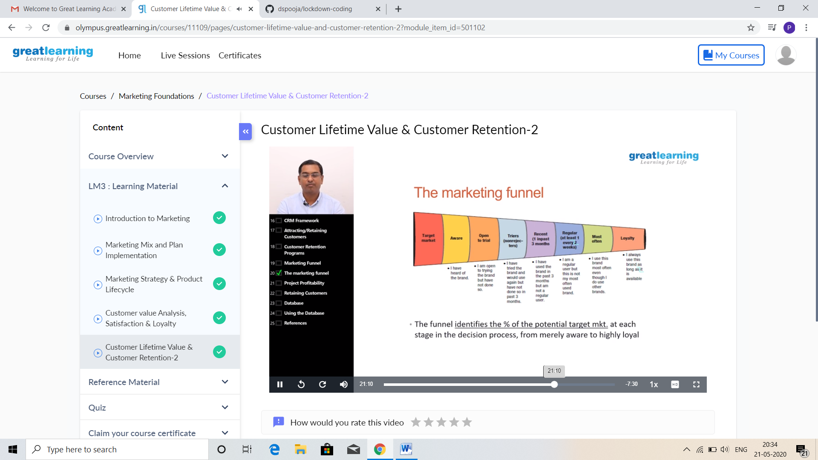

I refer the materials which as given in that course and I completed the course. This is my certificate

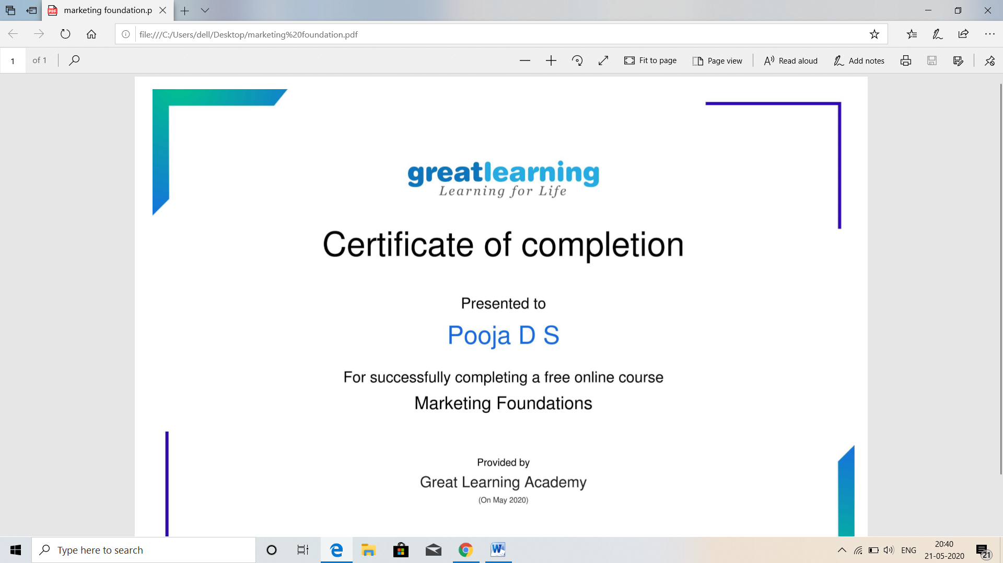

CODING CHALLENGES DETAILS:

Problem statement 1:

Write a C program to implement SRTF process scheduling. **An expected output of the program:**

Input: A set of processes with their burst time and arrival time

Output: The processes scheduled based on the arrival time and a smaller burst time.

Solution : Uploaded it in github

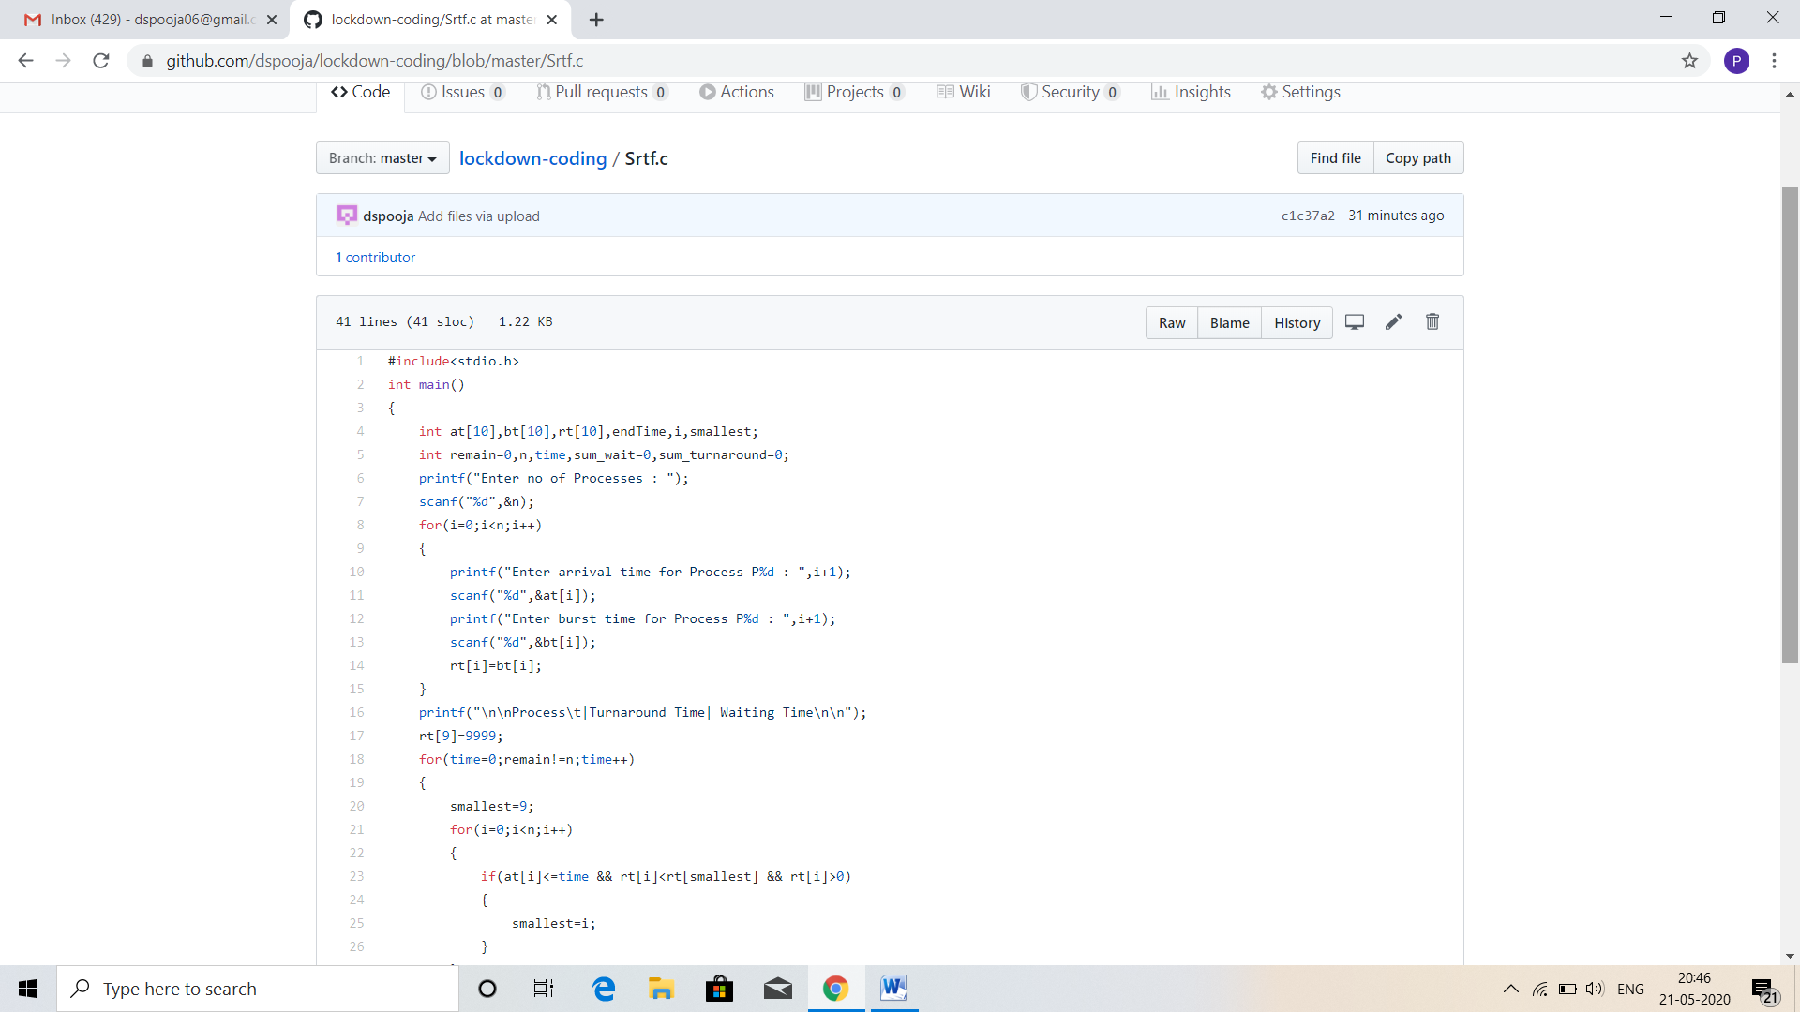

Problem statement 2:

Write C Program to create Singly Liked List with n elements and reverse the elements using C.

Hint: Create the SLL, and then Reverse the Link in SLL until Head becomes NULL. Each Time Reversing the Link, Head must be moved to next immediate node.

.

Solution: Uploaded in github.

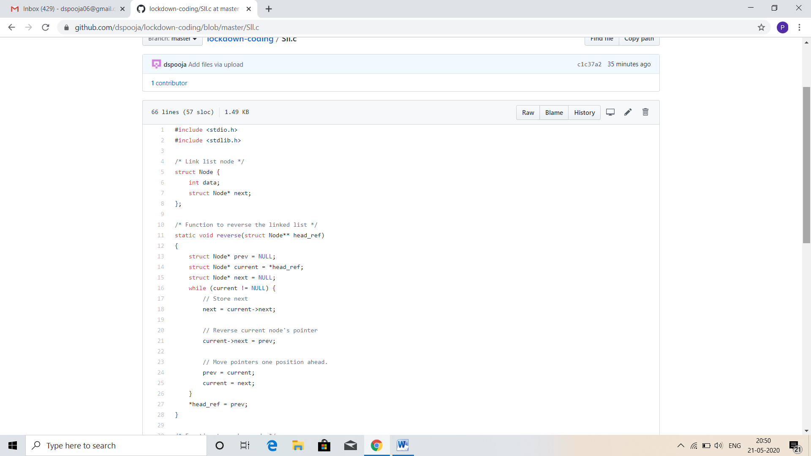

Problem statement 3:

Write a C program to construct a singly linked list by removing duplicate elements in the sorted linked list  
Description:

Take a sorted list and traverse the list. Compare the current node element with next adjacent node. If it is same then delete second element, if not retain. Finally print the resulting list.  
Sample output:  
Given list {1,2,2,3,3,3,4}  
Resulting list{1,2,3,4}

